ICS Correlation Functional Flow

Overview
This document will attempt to describe how the ICS Correlation function works in enough detail for all to understand. One very important thing to understand is that correlation is not a perfect process. Even though the idea of ICS is to correct for imperfect data it will only work within the bounds of the process described below. If we find the process is not sufficient for our correlation needs, it can be re-addressed in the future. For now, it is what it is.

Flow
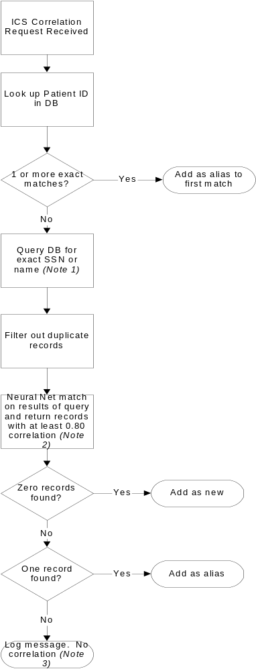

Note 1
This database query is for all records that exactly match the SSN or the name on the request. It is effectively first querying for exact SSN matches, then querying for exact name matches and combining these results (duplicates filtered in the next step). This mean that the only candidate records for correlation are those that at least match exactly SSN or name.

Note 2
The attributes that are considered for correlation are as follows:
1. Name (firstName, secondName and lastName separated by spaces)
2. SSN
3. Gender
4. Date of Birth
5. Address
6. Place of Birth
7. Maiden Name
8. Telephone Number
9. Drivers License Number

The rules for correlating Addresses in ICS are as follows:
In the ICS, Addresses are divided into four sections. street, city, state and zip. The street is comprised of the address1 and address2 fields separated by a blank space.

The street, city and state parts of the incoming record are 'alpha-compared' against their equivalents from the Database match. The zip parts are 'number-compared'. This process will result in four correlation factors for one pair Addresses. A pair comprising of one incoming Address and a matched Address from the Database.

Now, only those parts of the Address which actually were part of the incoming record are noted and their corresponding correlation factors are used to get an average correlation factor for this Address pair. This is used to determine a good match (0.8).

The rules for correlating Dates in ICS are as follows:
Any two Dates to be compared in ICS are first converted to the String representation of the format "MMddyyyy".

Then they are submitted to the neural net for comparison. If the neural net return a correlation between 0.45 and 0.55 (neither included), then we compare the year parts of the Dates.
If the years are off by 10 exactly OR if they are off by 100 OR if they are off by 2 years or less, we correlate them as 0.8 assuming it could be a typo.

Note 3
In this case, no correlation is performed but a message is logged that reads:
Illegal Argument -- The attempt to add a person has found multiple candidates that must be updated
This message is to be improved to include more information about what record failed correlation.

